Measures of Central Tendency: Mean, Median
Calculate the mean and the median of price for the following variables. Use GROUP BY in SQL
with the corresponding aggregate function.
● yr_built_grouped
● bedrooms
● waterfront
How do the mean and median differ across categories and why? Are these differences in line
with your expectations?
Analysis:
1.Waterfront homes(Outliers) cost about 3.5 times more than non-waterfront homes.
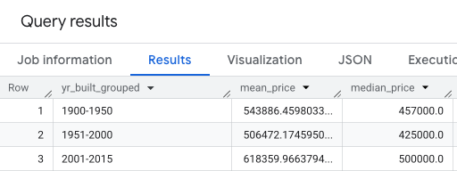
2.Homes built in 1900–1950 are actually the most expensive on average, even older than mid-century homes.The mean is always higher than the median in every year.
3.Some unusual data points were identified.For eg:One property recorded 33 bedrooms with a price of 640,000, which is likely a data entry error or a commercial property.
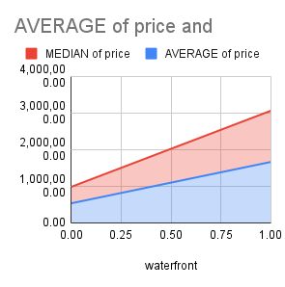
SELECT
yr_built_grouped,
AVG(price) as mean_price,
approx_quantiles(price,2) [offset(1)] as median_price,
FROM `census-2022-470714.kansas_city_real_estate.kc_house_prices`
GROUP BY yr_built_grouped
ORDER BY yr_built_grouped;

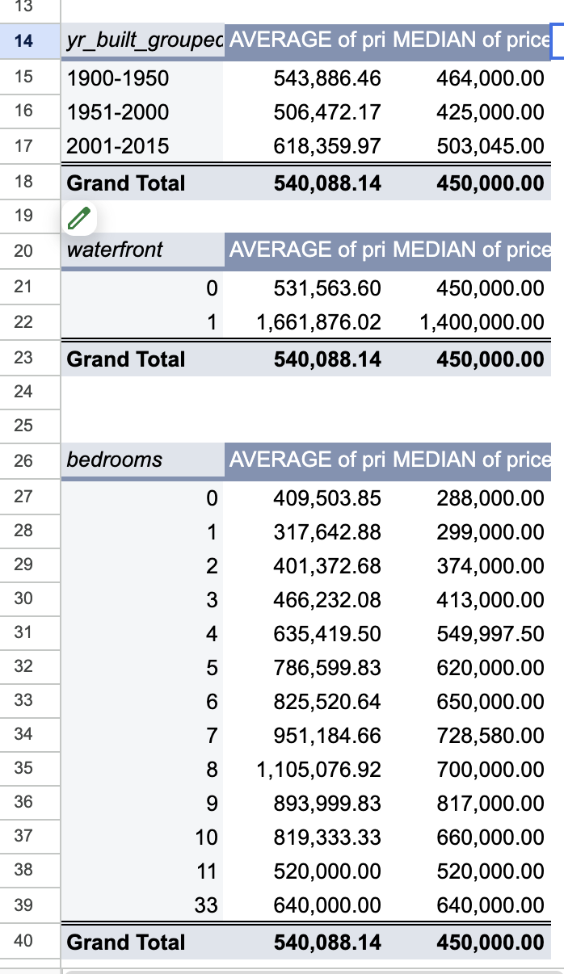

Measures of Spread: Range, Standard Deviation
Calculate the range, the standard deviation, and the coefficient of variation of price for the
following variables. Use GROUP BY in SQL with the corresponding aggregate function.
● yr_built_grouped
● floors
● waterfront
How do the range, standard deviations, and the coefficients of variation differ across categories
and why? Are these differences in line with your expectations? What does it mean when the
coefficient of variation differs between categories?

Analysis:
1.Houses with more floors tend to have a larger range and higher standard deviation, showing greater price variability.
2.Newer houses show a higher standard deviation, meaning their prices vary more compared to older houses.

SELECT
floors,
MAX(price)-MIN(price) AS range_price,
Round(STDDEV(price),2) AS Std_Deviation_price,
Round(STDDEV(price)/AVG(price),2) AS Coefficient_of_variation_price,
FROM `census-2022-470714.kansas_city_real_estate.kc_house_prices`
GROUP BY floors
order by floors;
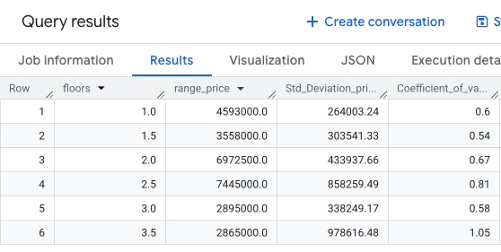
SELECT
yr_built_grouped,
MAX(price)-MIN(price) AS range_price,
Round(STDDEV(price),2) AS Std_Deviation_price,
Round(STDDEV(price)/AVG(price),2) AS Coefficient_of_variation_price,
FROM `census-2022-470714.kansas_city_real_estate.kc_house_prices`
GROUP BY yr_built_grouped
ORDER BY yr_built_grouped;

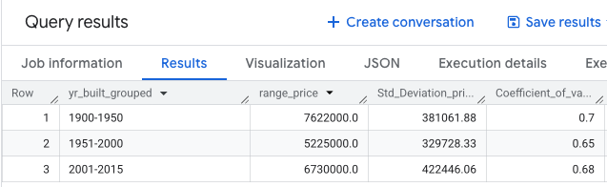

Correlation
Calculate the correlation between the following combinations of variables. Use GROUP BY in
SQL with the corresponding aggregate function.
● sqft_living vs price
● sqft_living vs sqft_lot
● yr_built vs price
Comment on the strength and direction of the resulting correlation coefficients. Are these
relationships in line with your expectations?

SELECT
Round(CORR(sqft_living,price),2) AS sqft_liv_price_corr,
Round(CORR(sqft_living,sqft_lot),2) AS sqft_living_lot_corr,
Round(CORR(yr_built,price),2) AS yr_built_price_corr,
FROM `census-2022-470714.kansas_city_real_estate.kc_house_prices`
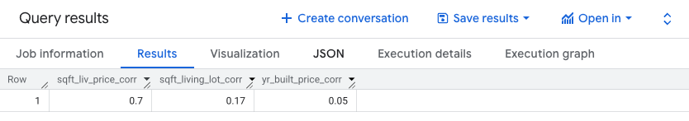

Analysis:
sqft_living vs price
1.There is a strong positive correlation between living area and price. This means that larger houses tend to be more expensive.
yr_built vs price
2.There is a weak to moderate positive correlation between yr_built and price.The house size has a greater impact on price than other factors.

